Project XYZ Test Plan
Test plan for the main test activities that will be conducted by Nezam team for XYZ project in the period from 25th of July to 22nd of August. All team members are required to read this document thoroughly.
─────────

Document Content:

Project Documents

Team responsibilities

Project Schedule

Main Deliverables

Defect Management & Defect Lifecycle

1-Project Documents
Figma Design
https://www.figma.com/XYZ
Confluence Requirements
Link Here
Azure Devops Project
https://dev.azure.com/XYZ
Defects Charter to report defects titles
Google Sheets
Telegram group for project discussions
https://t.me/XYZ
Swaggar Documentation
https://api-dev.XYZ.net

Credentials:
Admin Panel: ********
UserEmail: admin@gmail.com
Password: admin123
Website: *********
UserEmail: admin2@gmail.com
Password: admin1234

2-Team responsibilities:
Testing will be conducted in pairs, each pair access the project artifacts from one account:
1-Testet1 & Tester 2 (QA Lead & Defect Reviewer)
2-Tester 3 & Tester 4 (Web & iOS Testing)
3-Tester 5 & Tester 6 (Web & Android Testing)

2-Project Schedule:

Pre-testing Activities

Duration | Activity | Assignee
25th July “Thursday” | Review Figma Design by all members | All members
26th July “Friday” | Review Documents on Confluence | All members
27th July “Saturday” | Review project documents and known issues on Azure Devops | All members

Sprint 1 “28th July to 1st August”

Duration | Activity | Assignee
28th July | Front-end Web Testing and reporting only critical & high priority defects | Tester 5 & Tester 6
28th July | Admin Panel Testing and reporting only critical & high priority defects | Tester 3 & Tester 4
29th July | Front-end Web Testing and reporting only critical & high priority defects | Tester 3 & Tester 4
29th July | Admin Panel Testing and reporting only critical & high priority defects | Tester 5 & Tester 6
30th July | Mobile UI testing (Android) | Tester 5 & Tester 6
30th July | Mobile UI testing (iOS) | Tester 3 & Tester 4
31th July | Full Checklist-basedTesting Round ”Checklist will be provided by team leader” | All members
1st August | Full Persona-based Testing Round “Personas will be provided by team leader” | All members
4th August to 22nd August | Retesting & Regression testing | Methodology and assignments will be determined later
4th August to 22nd August | Creating Test Automation framework for the application | Methodology and assignments will be determined later

Sprint 2 “4th August to 22nd August”

Duration | Activity | Assignee
4th August to 22nd August | Retesting & Regression testing | Methodology and assignments will be determined later
4th August to 22nd August | Creating Test Automation framework for the application | Methodology and assignments will be determined later

3-Main Deliverables
-The main work product that will be delivered to the client is defect reports

Steps to create a defect report in Azure Devops:
1-Visit project page
Link here
2-Click on the (+) icon at the top left corner
3-Click on Bug to create a defect, this is the screen that will appear
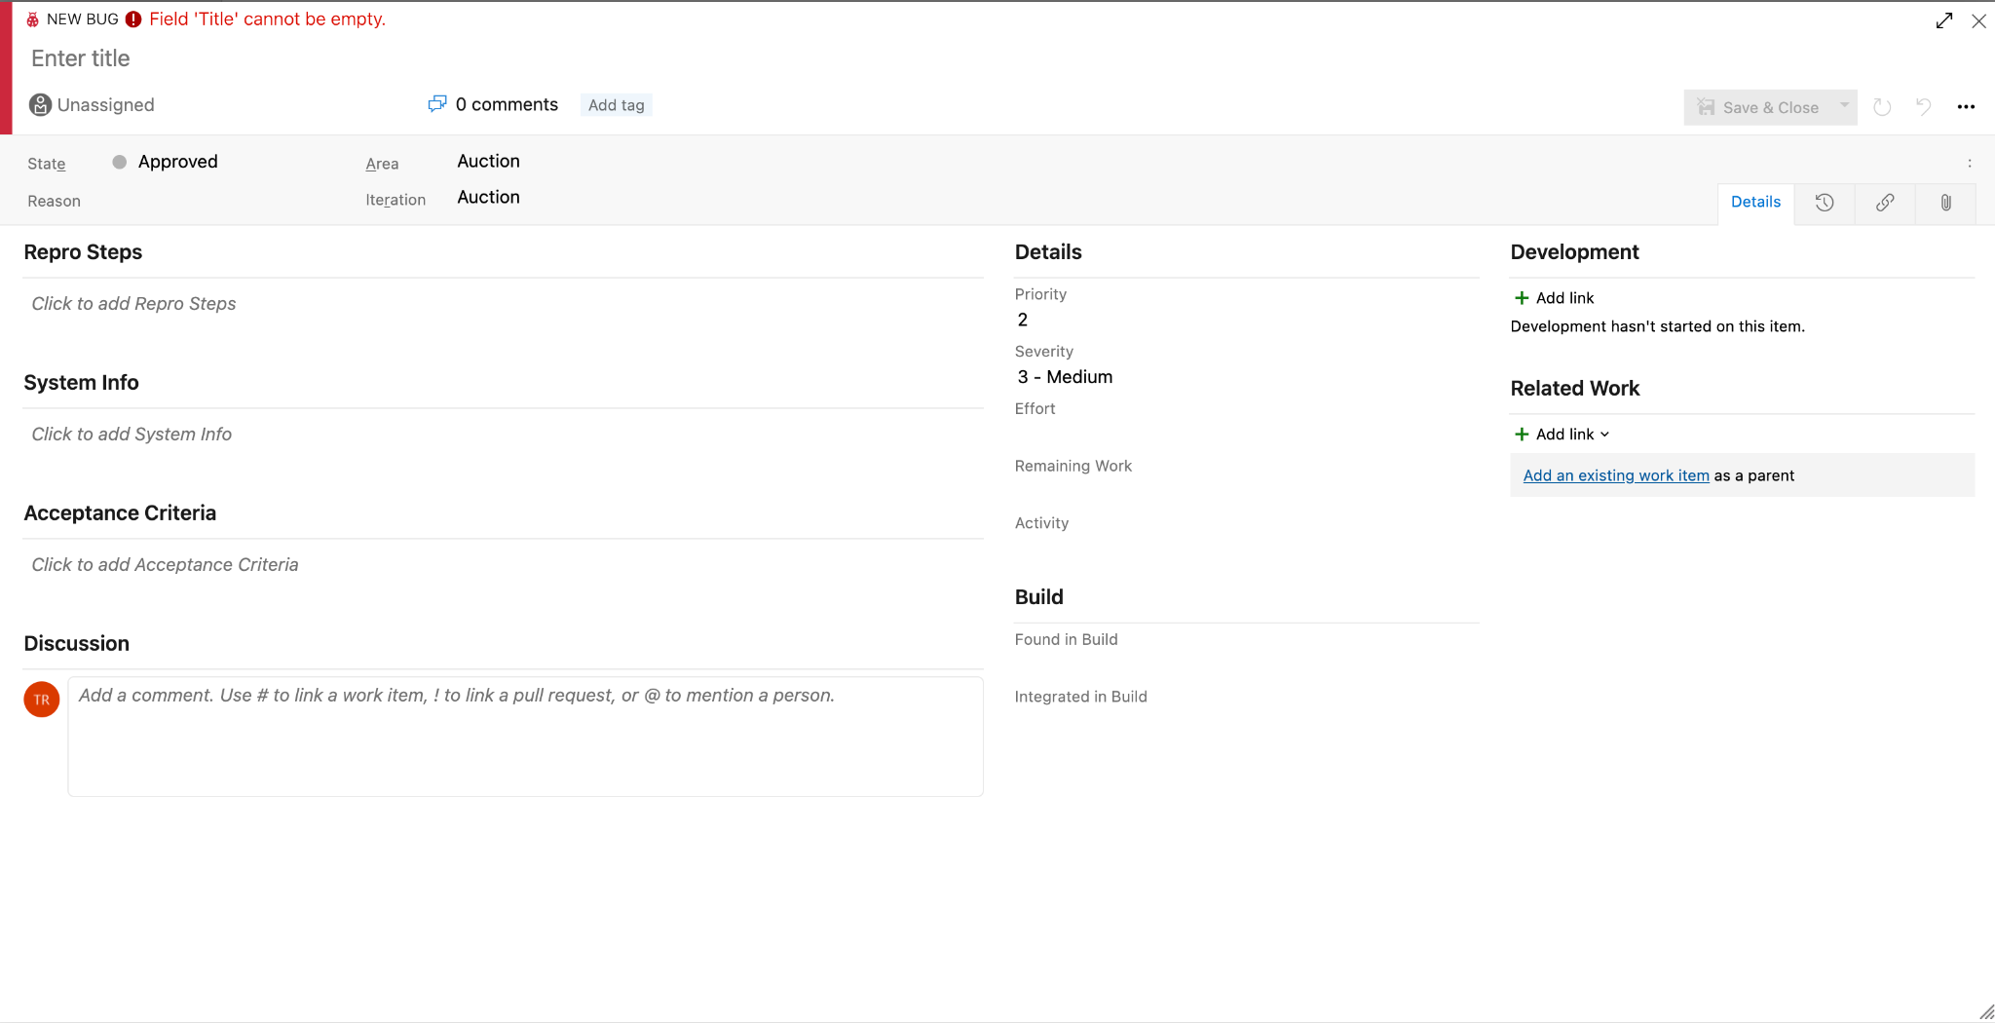
Defect Report writing Rules & Guidelines:
1-The title format should be:
Section -> Description
2-Repro Steps “This is steps to reproduce”
3-System Info: In this field, add two titles: Expected result & Actual result
4-Acceptance criteria: In this field, refer to any document that provides evidence of your defect “Requirements in confluence or Figma Design”
5-Priority and severity “1 is the highest value”
6-Activity - > Testing
7-Discussion: Add Screenshot to the Discussion, it should be full screen with a red
rectangle around the defective item
8-Assignee: This should be “Tarek Roshdy” because all defects should be reviewed by the test manager before they are approved

4-Defect Management & Defect Lifecycle:
Reporting Defects will follow the following flow:
1-Exploring a section using timeboxing “1 hour uninterrupted testing” and documenting defects titles in this document”
2-Searching Azure devops for any previously reported defect that identifies the same issue
3-If the defect is not a duplicate, report it to Azure Devops with required steps
4-Wait for feedback from QA leader regarding defect report quality
5-Correct the defect report ”if required” based on feedback from QA Leader

